We use meta argument lifecycle “ignore_changes” in order to ignore the changes that was made in the console.

Lets say we made an EC2 instance with a tag "Name" = "web-3"

And deployed it. Later in the console we added another tag lets say key is “alifa” and value is “khan”. Now when we again do terraform plan and apply, the changes made in the cli will be gone. We don’t want this to happen and want to keep the tags.

In order to do so we use

lifecycle {

    ignore_changes = [

      # Ignore changes to tags, e.g. because a management agent

      # updates these based on some ruleset managed elsewhere.

      tags,

    ]

  }

So now when any changes in tags are made in the cli it will be ignored. Changes in tags are being ignored.

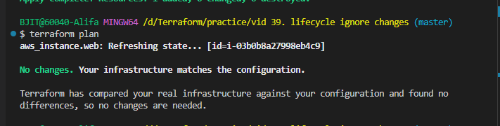

Additional outside knowledge that can be considered:

If we made changes in the console and now want to add in the code we can simply write terraform plan and then see the changes,

We can fix it until we see no changes to be made.